Data Structures & Algorithms
Open-Ended Lab Task
(FA24-BSE-070)

Problem Description:
Managing student records manually becomes difficult when the number of students increases. A Student Record Management System is required to efficiently store, organize, search, and sort student data in an academic environment such as a university or college.
This system helps administrators quickly access student information and improve data handling accuracy and efficiency.
Nature of Data
The system handles structured and dynamic data.
Each student record contains the following attributes:
- Name (String)
- Roll Number (Integer, Unique identifier)
- Department (String)
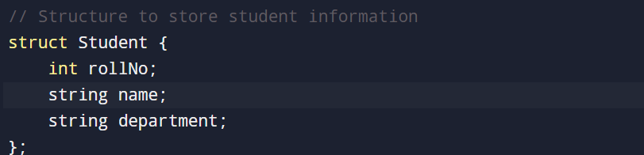
The data is dynamic because new student records can be added and existing records may need to be searched frequently.
Algorithms Used
- Sorting Algorithm: Bubble Sort
Used to sort student records based on roll number.
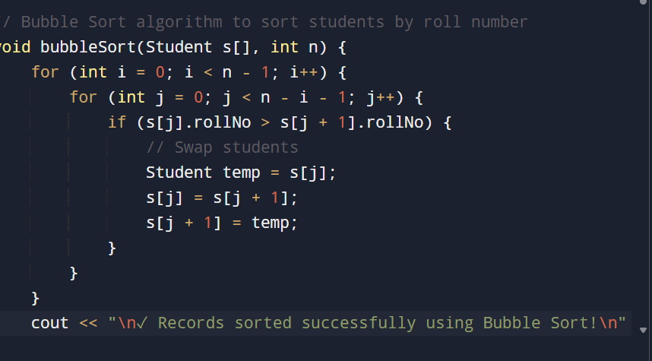
- Searching Algorithm: Binary Search
Used to efficiently search for a student record after sorting.
These algorithms ensure efficient data organization and retrieval.

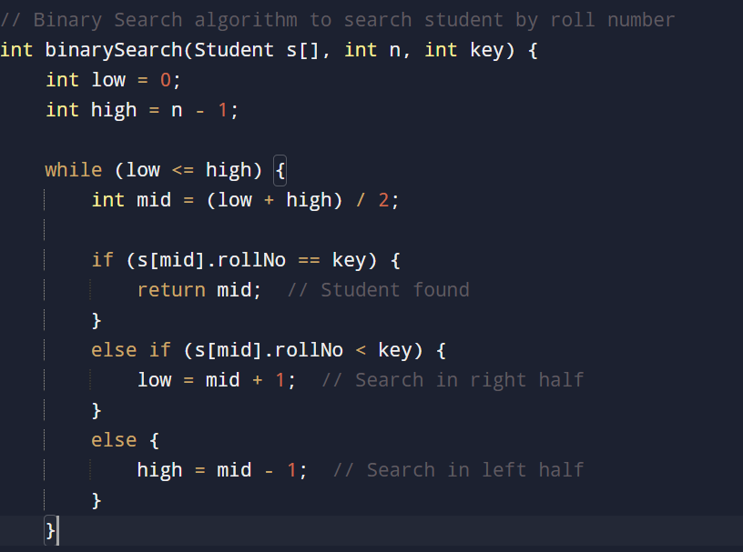

Programming Environment
- Programming Language: C++
- Compiler/IDE: Dev-C++, Code, Blocks, or Visual Studio.

Program Structure
The program is divided into logical and reusable functions:
- addStudents() – Adds student records
- displayStudents() – Displays all records
- bubbleSort() – Sorts records by roll number
- binarySearch() – Searches student by roll number
This modular design improves readability, debugging, and future scalability

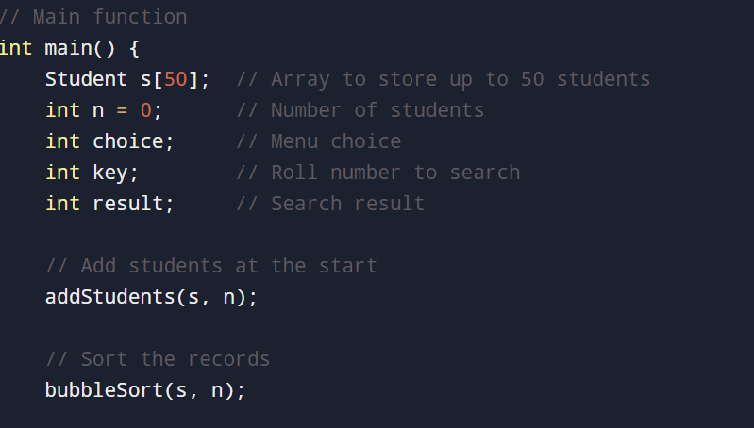

Implementation Details
- Student data is stored using an array of structures.
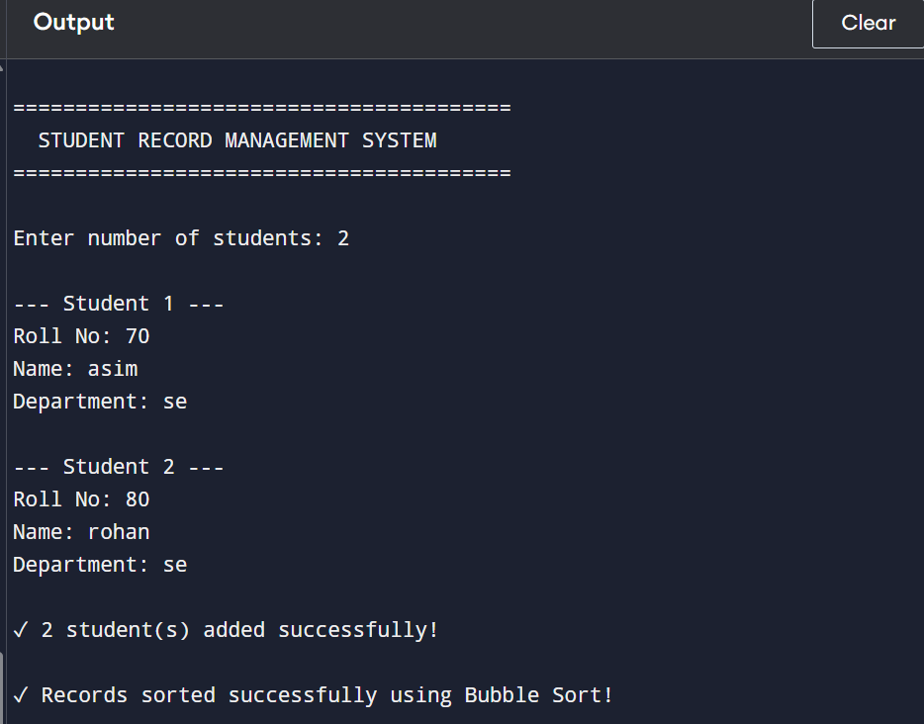

- Bubble Sort is applied before performing Binary Search.
- A menu-driven interface allows the user to interact with the system


Debugging Practices
- Ensured data is sorted before applying Binary Search.
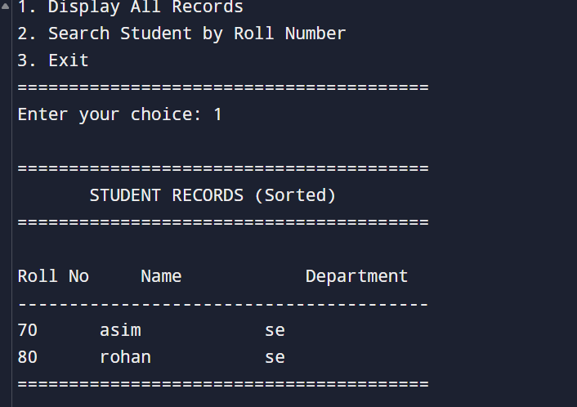
- Checked boundary conditions in loops.
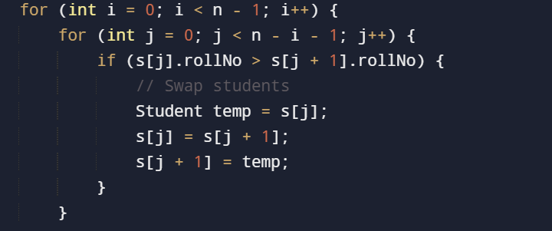
- Handled invalid roll number searches with proper messages.

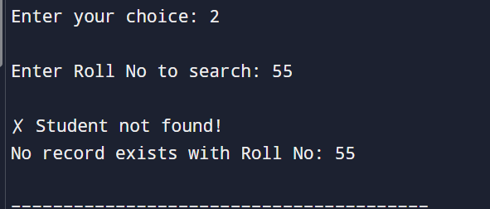
These practices ensure correct and error-free execution.
.
Performance Evaluation & Optimization
Time Complexity Analysis
The performance of the Student Record Management System is evaluated by analyzing the time
complexity of its major operations.
Bubble Sort:
- Best Case: O(n) (when data is already sorted)
- Average Case: O(n²)
- Worst Case: O(n²)
Bubble Sort compares each element with every other element, which makes it inefficient for large datasets.
Binary Search
- Time Complexity: O(log n)
Binary Search divides the search space into half at each step, making it significantly faster than Linear Search.
Display Operation
- Time Complexity: O(n)
- Each student record is printed once
.
Operations | Time complexity
Bubble sort | O(n²)
Binary sort | O(log n)
Display records | O(n)

Performance Bottleneck Identification:
The main performance bottleneck in the system is the Bubble Sort algorithm.
Why Bubble Sort is a Bottleneck:
- If the number of students increases (e.g., 1000 or more),
- Bubble Sort performs n² comparisons,
- This causes slow execution and poor scalability.
For example:
- 100 students → 10,000 comparisons
- ]1000 students → 1,000,000 comparisons

Optimization Analysis
Searching Optimization
Originally, Linear Search could have been used ;

- Linear Search Time Complexity: O(n) | - Binary Search Time Complexity: O(log n)

By sorting the data and applying Binary Search, the searching performance is significantly improved.
Comparison:
This optimization reduces search time drastically for large datasets.
Search type | Time complexity
Linear search | O(n)
Binary search | O(log n)

Sorting Optimization:
Although Bubble Sort is simple, better sorting algorithms can be used for large datasets:
Algorithm | Time Complexity
Bubble sort | O(n²)
Quick sort | O(n log n)
Merge sort | O(n log n)

Space Complexity Analysis:
The space complexity of the Student Record Management System is O(n).
Explanation:
- The program stores student records in an array of structures.
- Each structure contains:
  - Name
  - Roll Number
  - Department
- If there are n students, the array requires memory proportional to n.
Additional Space:
- Sorting and searching algorithms (Bubble Sort and Binary Search) use only a constant amount of extra memory for variables like loop counters and indices.
Conclusion
- Total Space Complexity = O(n)
- Space usage is efficient and suitable for managing student records in this system.

Optimization Explanation
Binary Search was used instead of Linear Search to improve searching efficiency.
Although Bubble Sort has higher time complexity, it is easy to implement and suitable for small datasets used in this system.

Conclusion
The Student Record Management System successfully demonstrates the practical application of data structures and algorithms.

